October Newsletter
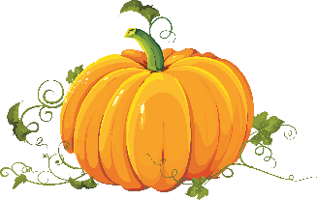
This Photo by Unknown Author is licensed under CC BY-NC

Reading – We are going to begin having small reading groups, where we work on phonics, reading and writing strategies, while others work in small groups on independent tasks. We are learning how to identify characters and the setting in stories. We are also learning how to retell a story (beginning/middle/end) and how to infer. We will be doing “Chaining” activities to help our students. This instruction practice gives students targeted instruction for analyzing and decoding words with particular spelling patterns. One grapheme is changed in each successive word, and students analyze the first word to determine how it has changed as they decode the next word. We will also be doing a unit on Nursery Rhymes through CKlA, which will be helping students recognize rhyme and patterns when reading.

Math – We will continue to practice counting and writing numbers. We will count and create sets of objects to 5 and 10. We will also talk about the different number/set configurations (array, linear, circular, scattered) and how we can count objects when they are in these configurations. We will also begin to break numbers apart and form number bonds. We will talk about 2D shapes and sort objects by different attributes.

Word Study –We are beginning to sound out CVC words (Consonant/Vowel/Consonant). We will continue to work on our Sight Words/Heart Words. Please remember to send back the Sight Word Folders on Thursdays and Fridays. This is when we do our assessments.

Writing – We are practicing how to use correct sentence structure (Begin with a capital letter, spaces between the words, sentence that makes sense, punctuation at the end) by copying sentences and using cut apart sentences. We will also begin to write our own sentences by using letters to make words and words to make sentences. We will draw pictures with details and label pictures with letters/words/sentences. We will begin to “sound out” words and write them phonetically.

Science/Social Studies –Community Helpers/Fire Safety, Scarecrows and Pumpkins, Bats/Spiders/Skeletons.
We will use our senses (science tools) to explore fall things (apples, pumpkins, leaves). We will compare these objects by color, size, etc. and use them to make graphs. We will observe weather changes and learn how those changes cause people, plants, and animals to do different things. I will be asking each student to bring in a little pumpkin (Cantaloupe size) for them to use for a Math/Science/Art activity, so go ahead and pick one up when you are out and about.

Fall Celebration
We plan to have Kindergarten/Grade Level Fall Celebration Rotations. We have not yet determined a date but will be notifying you after our WAVE Day this Wednesday, after we have had the opportunity to get together as a team to plan it. I will send out a sign up for things we will need for the celebration. If you are willing to help out by sending in an item or volunteering to help with a station/rotation, please let me know!

Home Connections:

- We are all authors! Point out to your child times when you are an author. (Making a grocery list, writing a check, etc.) It helps them to see that writing is important to everyone, every day.

- Writers put their ideas on paper. You are busy making dinner and your child wants to tell you a story. Encourage them to draw it in a picture (add letters/words if ready) and read it to you later when you are less busy.

- Be Mathtastic!
- Leaf Patterns – make a pattern with fall leaves (brown, red, brown, red etc.) then count
- Alike and Different – pick two trees and tell how they are alike and different
- Up Down and All Around – find a fall leaf and use it to practice position words (above your head, under a rock, behind a tree, beside your bike, etc.)
- Cereal Counters – use pieces of cereal to make number sets (1-10)

Parent/Teacher Conferences
We have completed the Statewide benchmarks in Reading/Phonics and Math. I would like to begin setting up some teacher/parent conferences to discuss your child’s results and progress so far in kindergarten. Of course, these conferences can be virtual or in person, depending on your comfort zone and availability. We can also set up phone conferences. I will be using the Signup.com webpage to help with the process. I will send you an email with the link, which will also give instructions on how to choose a date and time. Be looking for that later in the month.

MARK YOUR CALENDARS!
Oct 3 - National Custodial Workers Recognition Day
Oct 3- Candyman Kickoff K-2 9:00-9:30 Gym
Oct 7 - Fall Pictures
Oct 10 - Teacher Workday
Oct. 12th – Zing Zumm Field Trip (Godwin, Sparkman, Clemens, Hulst)
Oct. 13th – Zing Zumm Field Trip (Herring, Buckley, Kearney, Jordan)
Oct 19 - Early Release 12:30
Oct 28 - Fall Festival 5:30-7:30 COES Campus
Oct 31 - Halloween

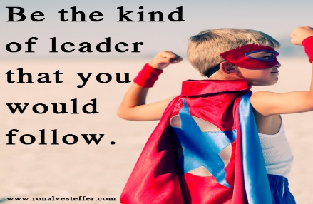
This Photo by Unknown Author is licensed under CC BY-SA-NC

